Deactivate Service Account

Version Control:

Use Case Name: |  | Deactivate Service Account
Use Case Owner: |  | Sumit Borade
Current Version |  | 0.2
Use Case Version History
Modified Date | Version |  | Modified By | Change Description
July 9, 2009 | 0.1 |  | Tom Schnarr | Initial Version
September 29,2009 | 0.2 |  | Sumit Borade | Updated with Feedback from YouSee

Brief Description:
This use case describes the process by a YouSee subscriber is deactivated from SMP. This use case will be subsequently call the details of other use cases to deactivate those services.

Related Documents
- YouSee SMP SOW2Architecture Requirements Document
- YouSee SMP SOW2 Business Requirements Document

Related Use Cases
- Deactivate Video service
- Deactivate Broadband and Voice Service
- Deactivate Broadband Service
- Deactivate mobile broadband service
- Terminate F-Secure key

Pre-Conditions
- Subscriber is currently a YouSee subscriber

Post-Conditions
- All services for this subscriber have been deactivated and the subscriber record is marked as deleted in SMP.

Use Case

Primary Flow Diagram
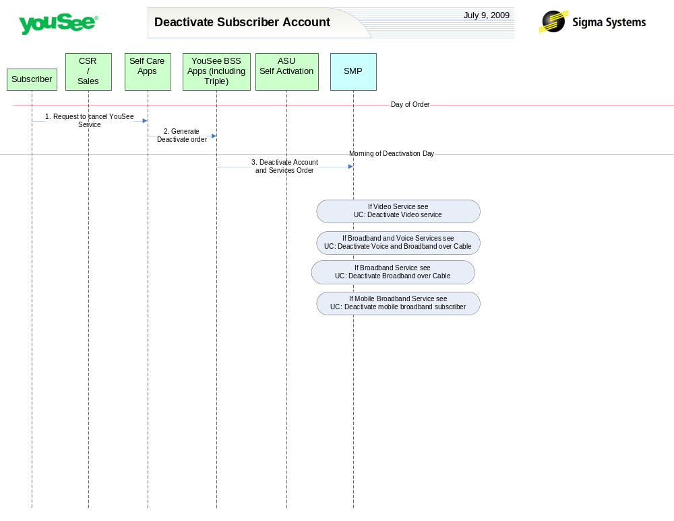

Primary Flow Detail
# | Actor: Key Action | Description | Alternate Flows/Details
Note: The first set of steps in this use case occurs on the day of order. This means the day the subscriber makes contact with YouSee to cancel all services.
 | Subscriber: Contacts YouSee to cancel services | Subscriber is currently a YouSee subscriber. They contact YouSee CSR team to cancel service.
 | CSR: Order is created in YouSee BSS applications | YouSee CSR generates order for fulfillment in the YouSee BSS Applications  The BSS components perform a variety of qualification and product catalog decomposition and communicate an order to SMP defining the subscriber, address, candidate CPE and services as ordered by the customer.
Note: The next step occurs at the time that the installation order goes active, namely the morning that the deactivation is due to occur.
 | YouSee BSS: Order is communicated to SMP | YouSee BSS (Triple) will communicate the order to SMP through SMP’s Order Management API. Triple will provide logical services and service attributes. SMP will be required to translate these service/service attributes to engineering level resources and resource attributes.
Note: Depending upon the set of services ordered, secondary Use cases are implemented for those specific services. See the following Use Cases:
- Deactivate Video subscriber with optional VoD
- Deactivate Voice and Broadband over Cable
- Deactivate Broadband Over Cable
- Deactivate new mobile broadband subscriber
- Terminate F-Secure key

